Identification Requirements for Voting
Under Texas law, voters who possess one of the seven acceptable forms of photo ID must present that ID at the polls when voting in person. Voters who do not possess and cannot reasonably obtain one of the seven approved forms of photo ID may fill out a Reasonable Impediment Declaration (RID) (PDF) at the polls and present an alternative form of ID, such as a utility bill, bank statement, government check, or a voter registration certificate.
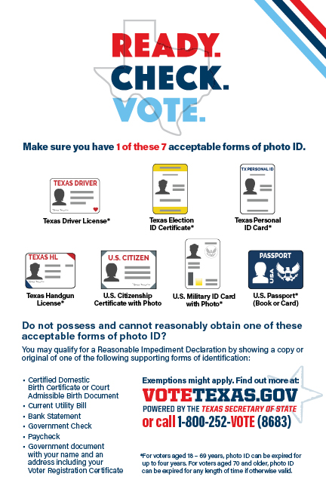

Here is a list of the acceptable forms of photo ID:
- Texas Driver License issued by the Texas Department of Public Safety (DPS)
- Texas Election Identification Certificate issued by DPS
- Texas Personal Identification Card issued by DPS
- Texas Handgun License issued by DPS
- United States Military Identification Card containing the person’s photograph
- United States Citizenship Certificate containing the person’s photograph
- United States Passport (book or card)
With the exception of the U.S. Citizenship Certificate, which does not expire, for voters aged 18-69, the acceptable form of photo identification may be expired no more than four years before being presented for voter qualification at the polling place. For voters aged 70 or older, the acceptable form of photo identification may be expired for any length of time if the identification is otherwise valid.
Election Identification Certificates are available from DPS driver license offices during regular business hours. Find mobile station locations here.

Here is a list of the supporting forms of ID that can be presented if the voter does not possess one of the forms of acceptable photo ID and cannot reasonably obtain one:
- copy or original of a government document that shows the voter’s name and an address, including the voter’s voter registration certificate;
- copy of or original current utility bill;
- copy of or original bank statement;
- copy of or original government check;
- copy of or original paycheck; or
- copy of or original of (a) a certified domestic (from a U.S. state or territory) birth certificate or (b) a document confirming birth admissible in a court of law which establishes the voter’s identity (which may include a foreign birth document).
After presenting one of the forms of supporting ID listed above, the voter must execute a Reasonable Impediment Declaration.

Procedures for Voting
When a voter arrives at a polling location, the voter will be asked to present one of the seven (7) acceptable forms of photo ID that is current or, for voters aged 18-69, expired no more than four years. Voters aged 70 or older may present one of the seven (7) acceptable forms of photo ID that is expired for any length of time that is otherwise valid. If a voter does not possess one of the seven (7) acceptable forms of photo ID and cannot reasonably obtain one, the voter may present a supporting form of ID and execute a Reasonable Impediment Declaration, noting the voter’s reasonable impediment to obtaining an acceptable form of photo identification, stating that the information contained in the declaration is true, that the voter is the same individual personally appearing at the polling place to sign the declaration, and that the voter faces a reasonable impediment to procuring an acceptable form of photo identification.

